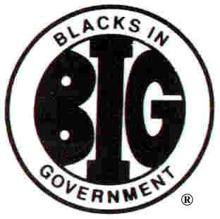

Region:

Blacks In Government
Certification form BIG 990-2
Calendar Year 2023

Name\DBA
(Chapter Name or Regional Council)

EIN:
(Chapter\Region EIN)

NATIONAL ORGANIZATION OF BLACKS IN GOVERNMENT (BIG) SUMMARY ACTIVITY FOR 12-MONTH PERIOD 01/01/2023 TO 12/31/2023 SUBMITTED TO NATIONAL OFFICE TO FACILITATE COMPLIANCE WITH INTERNAL REVENUE SERVICE REPORTING REQUIREMENTS

I, We certify, as attested by individual signatures below, that, under penalty of perjury, the authorization and the information submitted herewith for consideration and inclusion, as appropriate, for the annual tax reporting obligations of the central office of Blacks In Government (BIG) are true and complete.

(Print Full Name of President)

(Signature of President) (Date)

(Print Full Name of Treasurer)

(Signature of Treasurer) (Date)

One of America’s Most Influential Organizations

“Thank You For Thinking BIG”
BIG 2023 (990-2)

